BIOS LAB

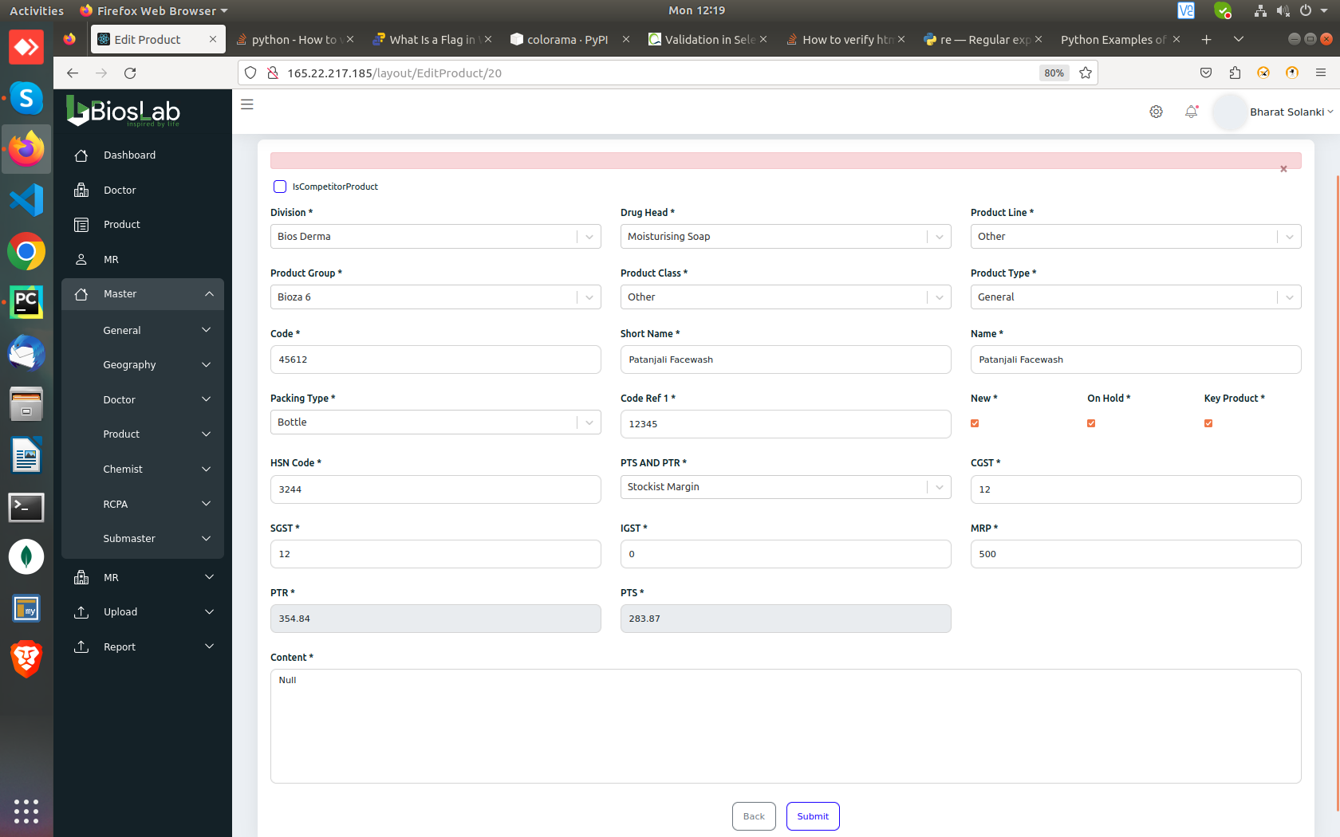
Edit product is not working, clicking submit without changing any values throws this error.

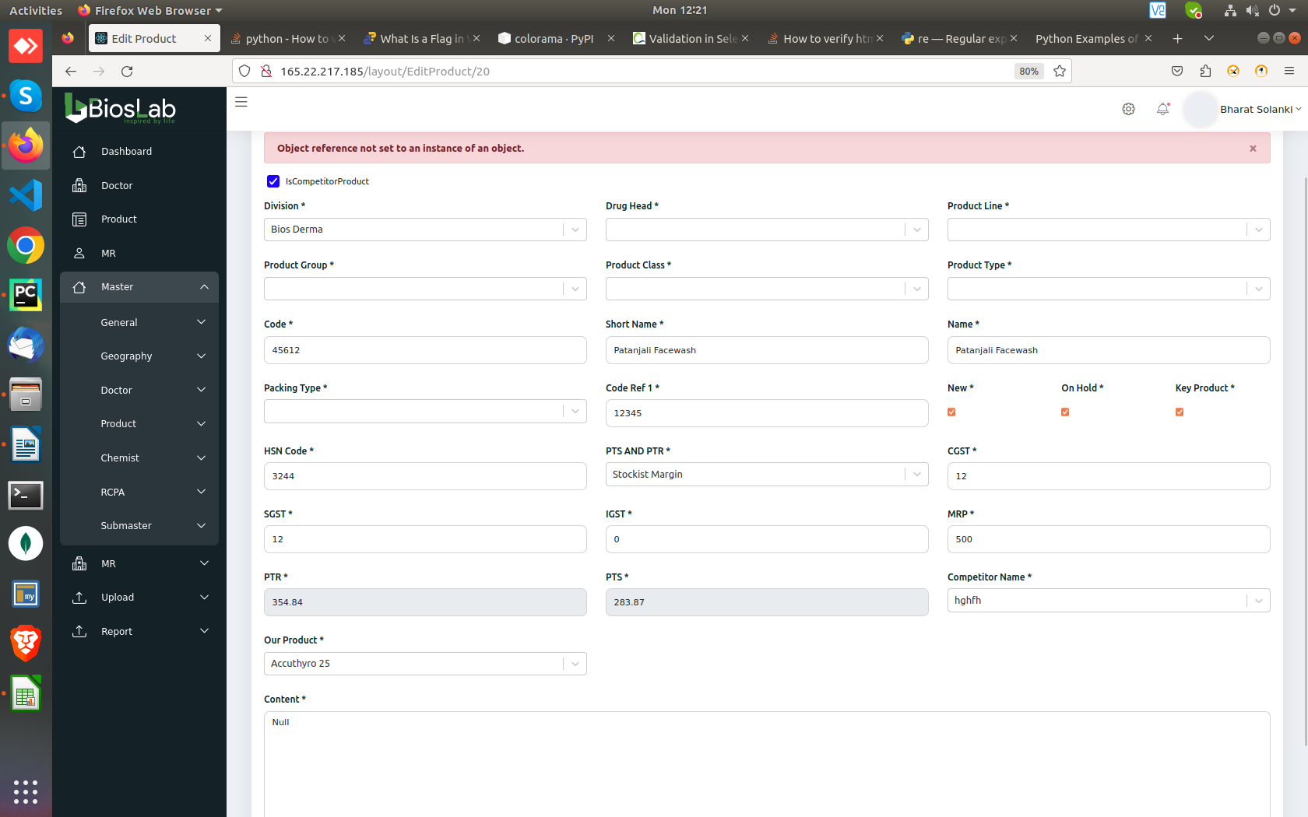
Adding competitor in Edit product doesn’t work.
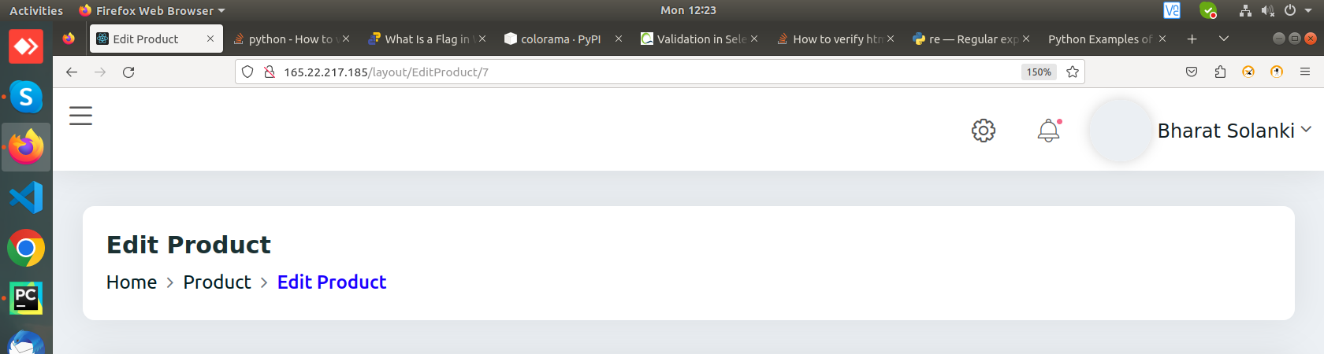
Clicking “Product” in edit product navigation options ( Home > PRODUCT > Edit Product) lands on a blank page

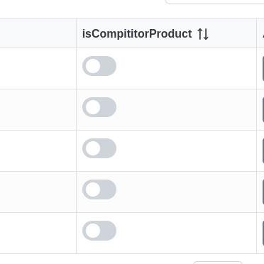

IsCompititorProduct button is not working in Edit product, as well as in

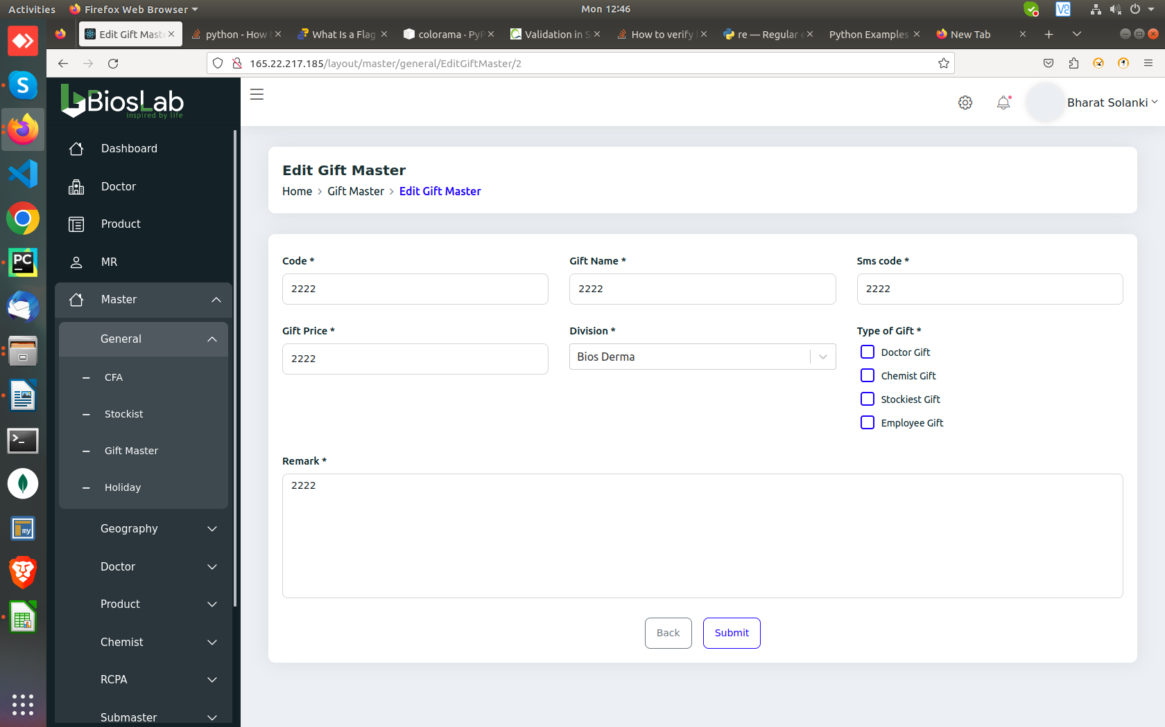
Master-->General-->Gift Master. New gift gets added without selecting the “Type of Gift”

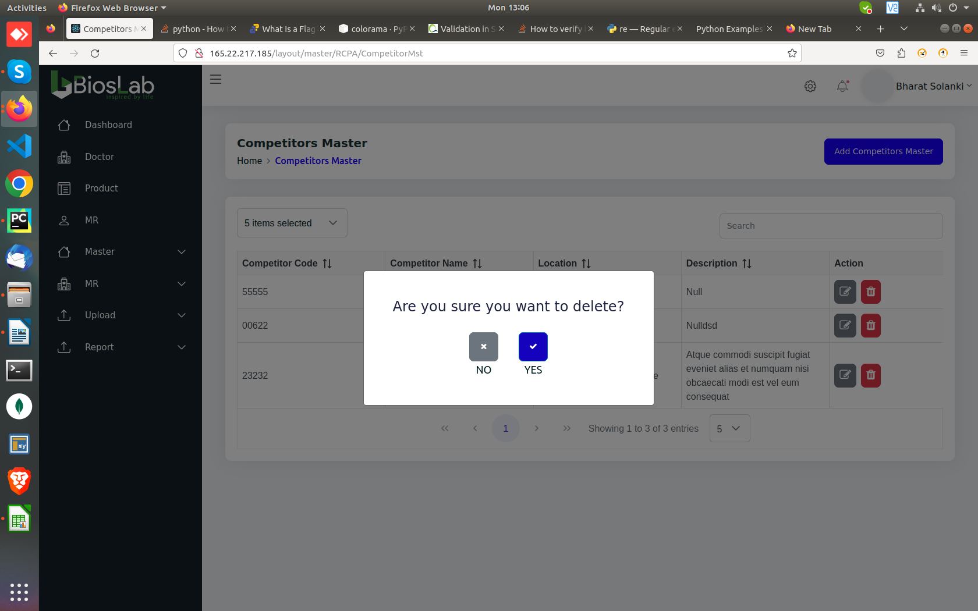
Master-->RCPA--> Competitors master, can’t delete/edit

